# Dive Deeper

I did a textual analysis for Term Frequency. I tried to see which words were most frequently used in the tweets by the Congressmen in the context of Lobbyists4America. I also made a word cloud for the same for easy visualization. We also made a word cloud for the commonly used hashtags. Stop words were eliminated when analysing the same.

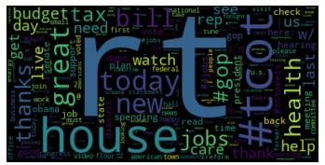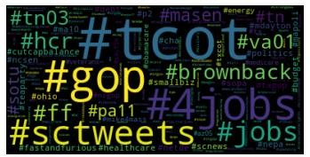

A correlation I found was between the retweet count and the sentiment analysis. People who had a positive sentiment were more active and retweeted on the cause far more.

# Go Broader

After seeing the wide range of sentiment analysis, I was in interested in seeing which politicians from which region were very positive about the cause. I also wanted to see if they retweeted other’s tweets that often, which would show if they are really interested in the cause and not just posting from time to time to garner votes. In general the sentiment seems to be on a slightly positive side.

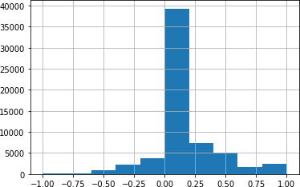

# New Metric

The metric I created was the Sentiment analysis of the twitter text data. I wished to see which Congressmen had the most positive approach towards the cause of Lobbyists4America over 2008-2012. We see some politicians who have a highly positive approach like, henrymmaster, RobWittman, BillHaslam etc.

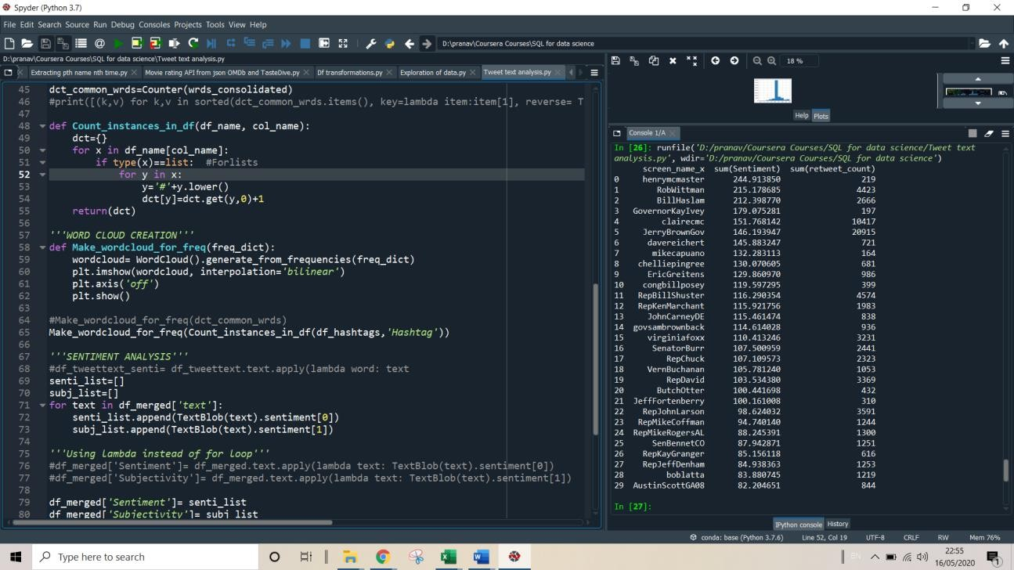

A real shocker was the subjectivity analysis, which is heavily skewed to 0 (Avg.:0.292), suggesting that almost all tweets are just factual which should not be the case for such a humanitarian cause.

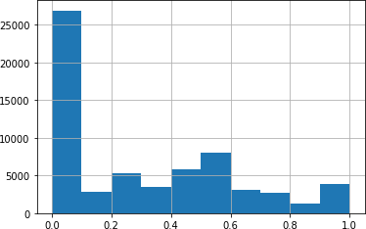

Therefore I tried to look at some tweets which had a 0 subjectivity (as per below). Turns out that people are talking about themselves but it is subtly related to the cause, as in the trip, meetings, conferences etc. are related to the cause but since it is not explicitly mentioned, the algorithm is unable to pick on it.

